Kubernetes Task

Setup minikube at your local and explore creating namespaces (Go through official documentation).

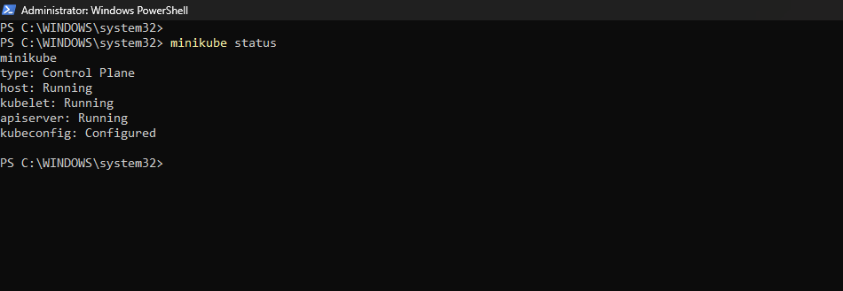

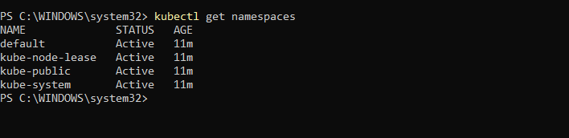

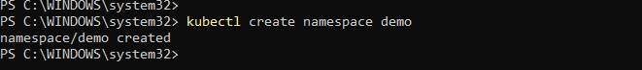

Name space created: Demo-yaml
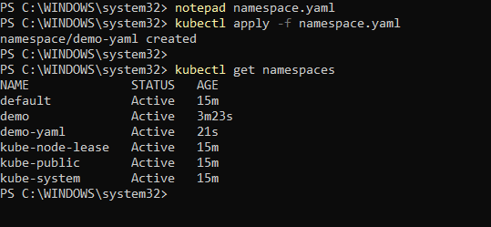

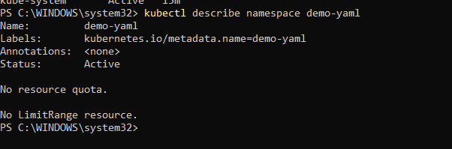

Deleting namespace
